Dear Parents,

Using the information on your PowerSchool Portal Password Letter you will need to set up a new account. Go to www.lutheranwestland.com click “Quicklinks” and select “PowerSchool for Parents and Students.”

- Click on Create an Account.

You will see a screen like this when you go to log in.  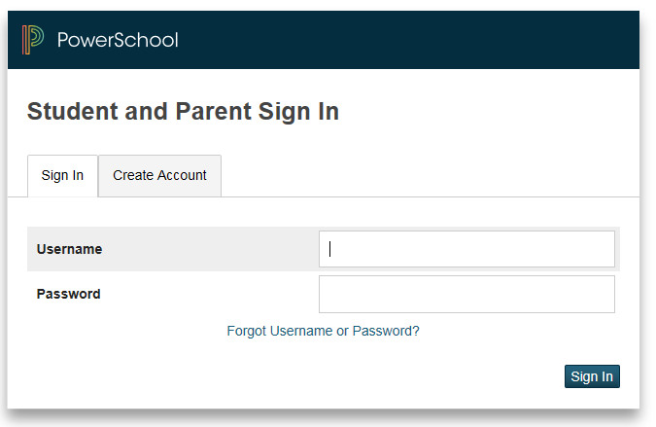 | 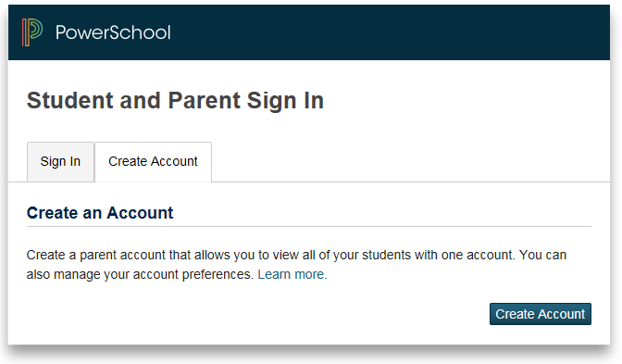

- Fill in the requested information on the next screen.

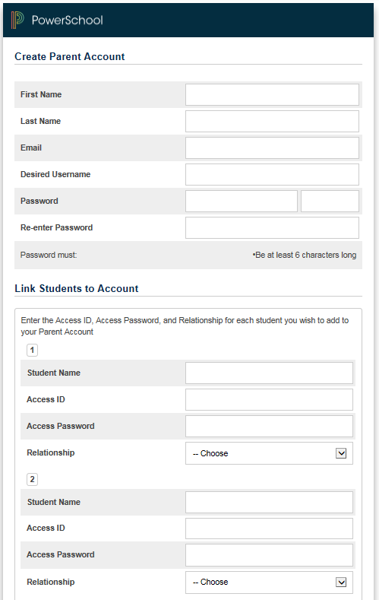 | - The “Desired User Name” is what you will log in with and the Password is what you will be using from now on.  - The Access ID and Access Password are the Parent/Guardian ones found on your PowerSchool Portal Password Letter.  - Be sure to use the drop down to state your relationship to the person.  - If you have more than one child at North, list them all here using your information for each student.  - This way you will be able to see all your children with one log-on.

